Search and Rescue Assistant

Overview

The objective of this project is to create a system that is easy to use and will aid search and rescue workers in an active search and rescue. It will do this by allowing search teams to check in their position automatically using a field device which will update a map that the search and rescue commander will be monitoring. The field devices will use advanced algorithms that will reduce their power consumption so that they can operate for long periods of time. The combination of field devices and computer software will help to reduce mistakes in communication and to provide detailed information for commanders automatically.

There will be two types of users for the system, search team leaders, and the search and rescue commander. A search team leader in charge of a specific search team, and helps facilitate communication between the commander and the team. The commander is the one who is organizing, directing, and keeping track of teams. Usually they will have several people at base camp supporting them, such as those in charge of getting food or working with software to aid in the operation.

Team Leaders

For a search team leader, they will be using the device to get their current GPS position, and to send information back to the commander. In the first case, the user will press a button and the device will display a ‘wait’ message on the screen. The device will then try to acquire the current position. If no position could be acquired then it warns the user that no signal was found and that the device may be unable to send information to others. If the device was successful in acquiring its position it will then display the GPS coordinates to the user. In the second case the user presses a separate button and the device will tell the user to wait. It will then attempt to acquire its GPS position, and send that information back to the commander. To do this it needs to establish connection to a receiver device that is attached to the commander’s computer. Once a connection has be established it will send the devices ID number along with the GPS coordinates. After successfully receiving all of the information the receiver will send a ‘received’ signal to the device. When the device receives that signal it will tell the user that the information was successfully sent. Should the device fail to acquire a GPS signal or it does not receive the correct message from the receiver, it will then inform the user of the error.

When a third button is pressed then the device will save information about the current rescue operation on its memory and shut then shut the device down. After the team leader has replaced the batteries they will turn the device back on. If there was a search operation saved on the device, then at startup the device will ask the user if they want to load the search information from memory and continue the search or if they want to scrap the information. If the user chose to continue the search then the device will tell the user it is loading, and after a short amount of time inform the user that all information was loaded. They can then continue with the search operation.

Commander

Unlike team leaders, the commander will only be using the desktop software. During the beginning of the search operation the commander needs to setup the program. To do this, the commander opens the program then hits a button labeled ‘start new search.’ The commander then needs to input information about each search team, such as the device ID associated with a team, the team’s size, and the teams color. Once all that information has been given the commander then needs to give the GPS location of the base. The program will then look at a list of maps stored on the computer and determine which map has that GPS location. It will then display that map to the user and the search and rescue operation has begun.

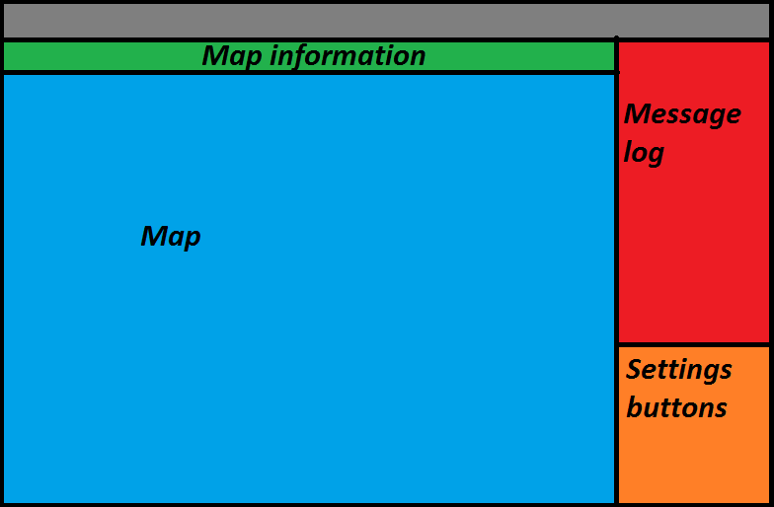

There are three main parts to the program’s UI, the map and map information, the message log, and the settings buttons. After a search has been started the user will mostly interact with the message log and the settings buttons, the map will not have any user interaction. It will only show where team leaders are, areas they have searched and areas that rescue workers cannot legally enter.

*Message Log*

This area will display information about when a rescue team sent a signal to the receiver, their GPS coordinates, the team leader’s name, and the color of the team. Once there are enough messages, the message log screen will receive a scroll bar so the commander can scroll through check-ins.

*Settings Buttons*

This section will have a number of buttons to allow the commander to edit a number of attributes about the current search operation.

* Edit teams

This will allow the commander to edit the attributes of teams, such as the team size, the commander, the device ID and the color. This allows flexibility in case people leave or join a group or if a device is damaged. When the commander presses this button a pop up window with a scroll bar will appear. The window will have a list of the teams displaying their team name and color. Next to each team will be an edit button. Once pressed this will change the window into an editing window which will have sections to fill in. At the end of the team list will be a button labeled, ‘add team’. This allows the commander to add teams to an active search and rescue operation.

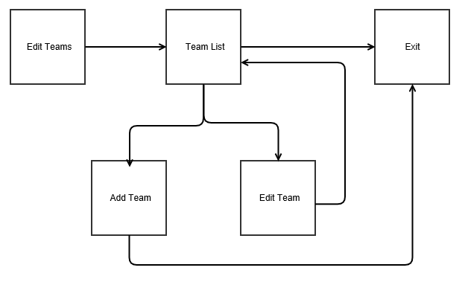

* Edit Map

If there is something wrong with the map or the program has loaded the wrong map then the commander can manually select a map to load. Once pressed the user will be asked if they want to change the map. This is because if they change the map it will discard current markers on the map and start the rescue anew. A standard Window’s navigation window opens, similar to the ones you see when someone wants to open a document. The user then navigates manually to the map that they want.

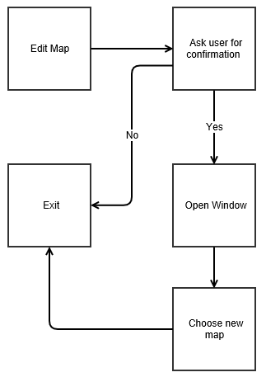

* Check Receiver

This is used to ping the receiver in case there are problems communicating with it. A pop up saying ‘Checking receiver’ will appear with a cancel button on it. The program will then attempt to communicate with the receiver and make sure that everything is fine. After a successful communication a new popup window will appear saying the receiver is fine. Should if fail to communicate with the receiver a window will pop up saying that there is a problem with the receiver and to check connection.

* Send out message

This will send out a message to all devices for team leaders to read. While it may be redundant as radios will be used in tandem with these devices it is a useful feature to have. When this is a pressed a popup window will appear with a message telling the user the maximum number of characters allowed and a text box the commander can type in to. After that they press the okay button at the bottom of the popup and the message is sent out to all devices.